In this section we explore rational functions, which have variables in the denominator. A rational function is a function that can be written as the quotient of two polynomial functions.

A **rational function** is a function that can be written as the quotient of two polynomial functions $P(x)$ and $Q(x)$.

$$f\left(x\right)=\frac{P(x)}{Q(x)}=\frac{a_{p}x^{p}+a_{p-1}x^{p-1}+…+a_{1}x+a_{0}}{b_{p}x^{q}+b_{q-1}x^{q-1}+…+b_{1}x+b_{0}}, Q(x)≠0$$

# Using Arrow Notation

To describe the behavior of these types of graphs we have to be careful about which “end” we are referring to.

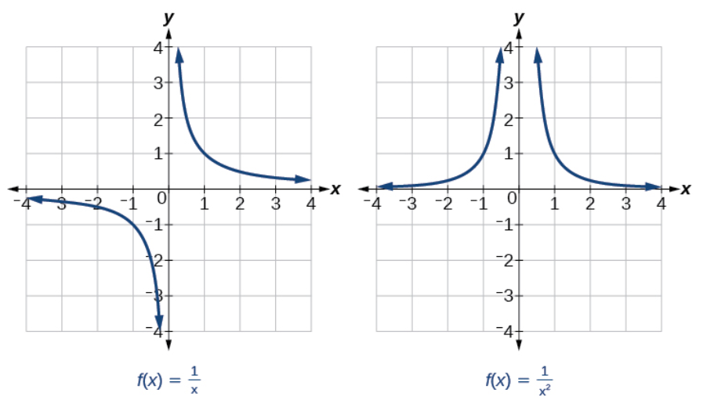

We can see by observing the graphs above, that “ends” can approach different values (not always just $∞$ or $-∞$).

| Symbol | Meaning |
| --- | --- |
| $$x→a^{-}$$ | $x$ approaches $a$ from the left ( $x<a$ but close to $a$) |
| $$x→a^{+}$$ | $x$ approaches $a$ from the right ( $x>a$ but close to $a$) |
| $$x→∞$$ | $x$ approaches infinity ( $x$ increases without bound) |
| $$x→-∞$$ | $x$ approaches negative infinity ( $x$ decreases without bound) |
| $$f\left(x\right)→∞$$ | the output approaches infinity (the output increases without bound) |
| $$f\left(x\right)→-∞$$ | the output approaches negative infinity (the output decreases without bound) |
| $$f\left(x\right)→a$$ | the output approaches $a$ |

We use **arrow notation** to show that $x$ or $f(x)$ is approaching a particular value.

Rational functions, like the ones shown above, often have vertical asymptotes due to the variables in the denominator.

A **vertical asymptote** of a graph is a vertical line $x=a$ where the graph tends toward positive or negative infinity as the inputs approach $a$. We write

As $x→a, f(x)→∞$ or as $x→a, f\left(x\right)→-∞$

For the function $f\left(x\right)=\frac{1}{x}$, we can see there is a vertical asymptote at $x=0$. We can also see that as $x$ gets closer and closer to 0 (or as $x$ approaches 0), the graph can either go up (towards infinity) or down (towards negative infinity) depending on which direction we are approaching 0. This is known as the **local behavior**.

Coming from the right side, we can use arrow notation to describe the behavior:

As $x→0^{+}, f(x)→∞$

Coming from the left side, we can use arrow notation to describe the behavior:

As $x→0^{-}, f\left(x\right)→-∞$

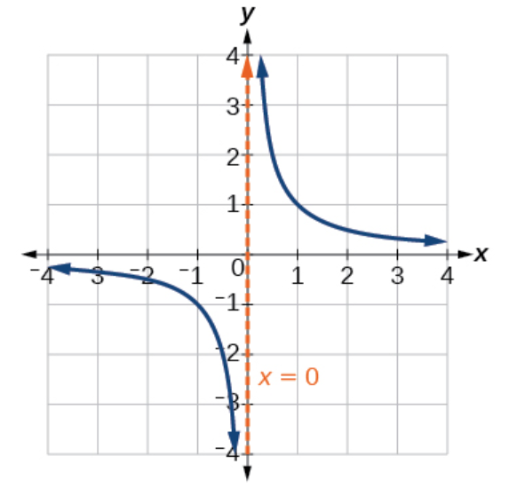 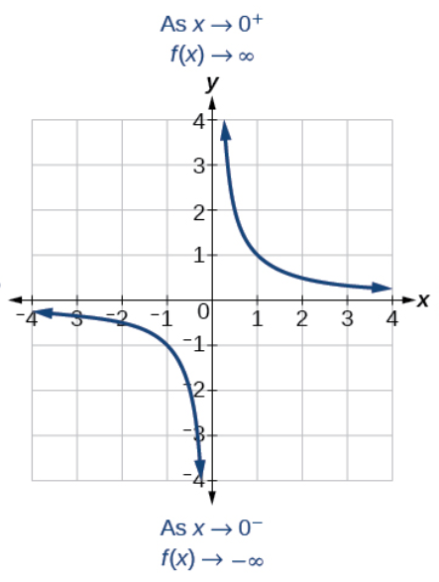

Similarly, just like with polynomial functions, we can observe what happens as $x$ approaches infinity and negative infinity (also known as **end behavior**).

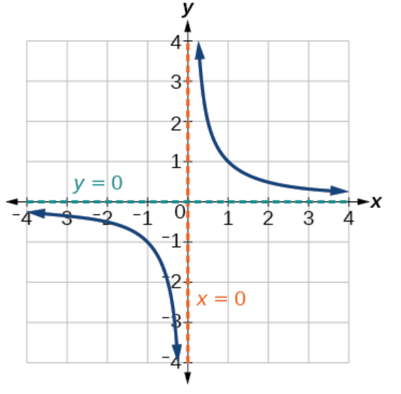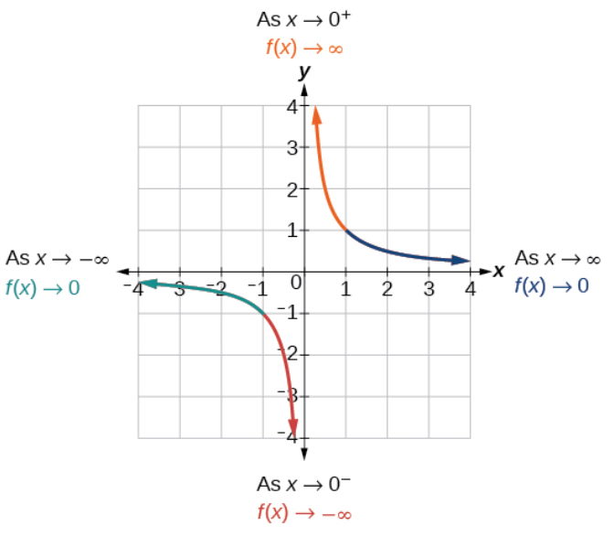

As the values of $x$ approach infinity, the function values approach 0.

As $x→∞, f(x)→0$

As the values of $x$ approach negative infinity, the function values approach 0.

As $x→-∞, f(x)→0$

Notice that the function approaches 0, but never actually reaches 0; it seems to level off as the inputs become large. This behavior creates a horizontal asymptote.

A **horizontal asymptote** of a graph is a horizontal line $y=b$ where the graph approaches the line as the inputs increase or decrease without bound. We write

As $x→∞, f(x)→b$ or as $x→-∞, f\left(x\right)→b$

Examples: Use arrow notation to describe the end behavior and local behavior of the functions below.

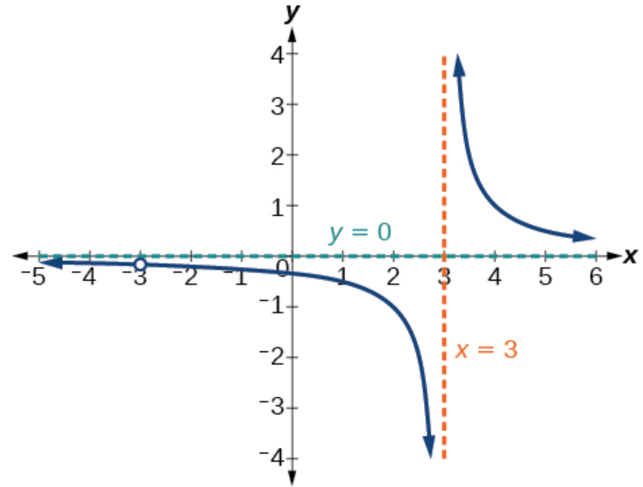

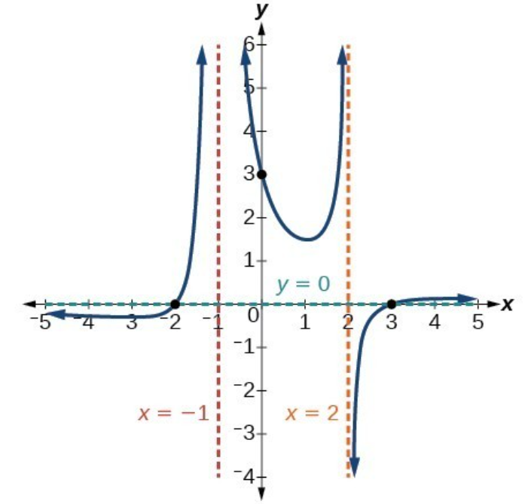

# Finding the Domains of Rational Functions

Since the denominator of a rational function cannot be 0, there will be values where the function does not exist or is undefined. So that value will not be in the domain of the function.

The **domain** of a rational function includes all real numbers except those that cause the denominator to equal zero.

We can find the domain of a rational function by

Examples: Find the domain of each of the following rational functions.

$f\left(x\right)=\frac{x+3}{x^{2}-9}$

$f\left(x\right)=\frac{4x}{5(x-1)(x-5)}$

$f\left(x\right)=\frac{x^{2}-1}{x^{3}+9x^{2}+14x}$

# Identifying Removable Discontinuties and Vertical Asymptotes of Rational Functions

By looking at the graph of a rational function, we can investigate its local behavior and easily see whether there are asymptotes. We may even be able to approximate their location. Even without the graph, however, we can determine whether a given rational function has any asymptotes and calculate their location.

Sometimes rational functions can have removable discontinuities, or holes. These are places in the graph where the function is not defined and are indicated by an open circle.

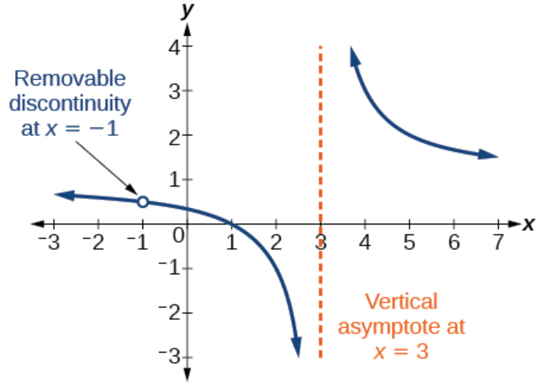

A **removable discontinuity** occurs in the graph of a rational function at $x=a$ if $a$ is a zero for a factor in the denominator that is common with a factor in the numerator.

Given a rational function, we can identify any removable discontinuities and/or vertical asymptotes by

1. Factoring the numerator and denominator.

2. Noting any restrictions in the domain of the function.

3. Checking for removable discontinuities (holes). If there are common factors in the numerator and denominator that can be canceled, that is the location of the hole. Set the common factor to 0 and solve.

4. Reducing the expression by canceling common factors in the numerator and denominator.

5. Noting any values that cause the denominator to be zero in this simplified version. These are where the vertical asymptotes occur.

Examples: For each of the following, find the vertical asymptotes and removable discontinuities.

$f\left(x\right)=\frac{x-2}{x^{2}-4}$

$f\left(x\right)=\frac{x^{2}-25}{x^{3}-6x^{2}+5x}$

**Identifying Horizontal Asymptotes of Rational Functions**

While vertical asymptotes describe the behavior of a graph as the output gets very large or very small, horizontal asymptotes help describe the behavior of a graph as the input gets very large or very small. Recall that a polynomial’s end behavior will mirror that of the leading term. Likewise, a rational function’s end behavior will mirror that of the ratio of the function that is the ratio of the leading terms.

• The horizontal asymptote of a rational function can be determined by looking at the degrees of the numerator and denominator.

• If the degree of the denominator is larger than the degree of the numerator, there is a horizontal asymptote at $y=0$.

• If the degree of the denominator is the same as the degree of the numerator, there is a horizontal asymptote at $y=\frac{a_{n}}{b_{n}}$, where $a_{n}$ and $b_{n}$ are the leading coefficients of $p(x)$ and $q(x)$ for $f\left(x\right)=\frac{p(x)}{q(x)}, q(x)≠0$.

• If the degree of the denominator is smaller than the degree of the numerator by one, we get a slant asymptote (i.e. no horizontal asymptote).

Examples: For each of the functions below, idenify the horizontal or slant asymptote.

$g\left(x\right)=\frac{6x^{3}-10x}{2x^{3}+5x^{2}}$

$h\left(x\right)=\frac{x^{2}-4x+1}{x+2}$

$g\left(x\right)=\frac{x^{2}+4x}{x^{3}-8}$

# Graphing Rational Functions

Now that we have seen all the different characteristics of rational functions, we should be able to graph them and identify them.

Example

1. Graph the following rational function and answer the following questions.

$$f\left(x\right)=\frac{(x+2)(x-3)}{{\left(x+1\right)}^{2}(x-2)}$$

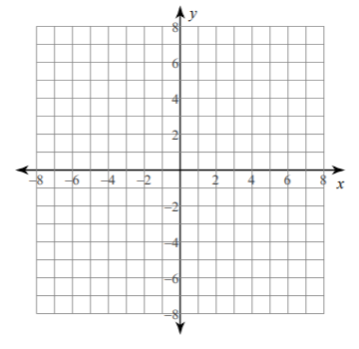

Domain:

Range:

Hole(s):

Vertical Asymptote(s):

Local Behavior for each asymptote:

$x$-intercept(s):

$y$-intercept(s):

Horizontal Asymptote(s):

End behavior:

As $x→∞, f(x)→$

As $x→-∞, f(x)→$

# Solving Applied Problems Involving Rational Functions

Now that we’ve seen numerous ways to analyze rational functions, we should be able to solve some applied problems.

Examples:

1. The concentration $C$ of a drug in a patient’s bloodstream $t$ hours after injection is given by $C\left(t\right)=\frac{2t}{3+t^{2}}$. What happens to the concentration of the drug as $t$ increases?
2. An open box with a square base is to have a volume of 108 cubic inches. Find the dimensions of the box that will have minimum surface area. Let $x$ =the length of the side of the base.